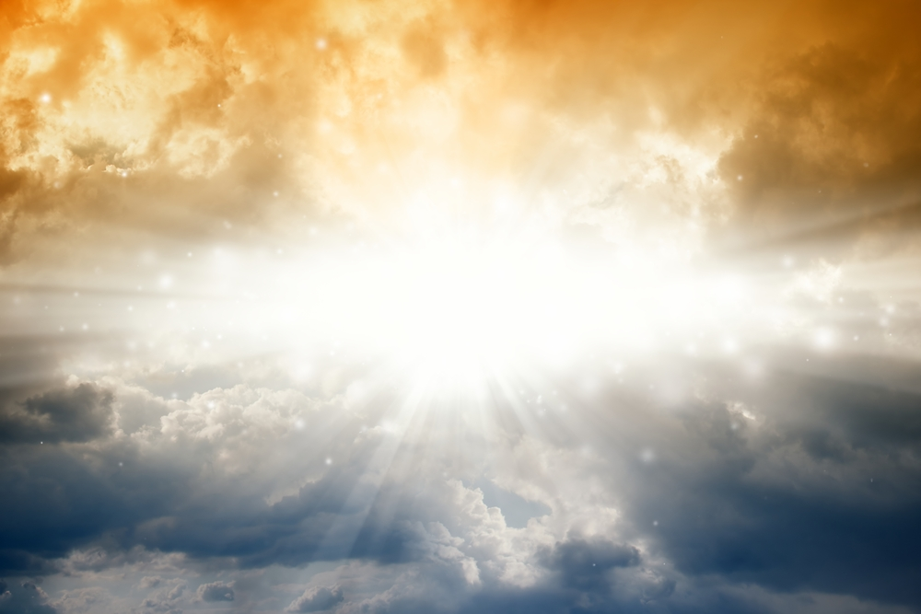
Your Unique

Personal Archetypal Chart

Personal Goddess, Masculine Akhbaka, Elemental & Starchild Charts.

There is a way to identify the inherent Archetypes which are major components & which dominate your individual Soul Structure.
One way to understand these inherent Archetypal Energies is to think of them as the aspects of Prime Creator & at the same time, the aspects of " Great Spirit" which make up your individual soul structure.
At Essential Energies we are able to identify these Goddess, Masculine Akhbaka, Elemental & Star-Person, aspects within your soul that are the fundamental & inherent " bits" of Prime Creator chunked down to form your unique Soul & Physical Being.
When you order your personal Archetypal chart from us it will enhance your understanding of who & what you are. It will help pinpoint the energies linking you to the whole of creation & how these support your personal destiny & life purpose.
Knowledge of these energies highlights which areas of your inner technology need energetic support, activation or repair. Energy Healing & support is then offered to you in the form of Vibrational Essences & Elixirs from Essential Energies. These can propel you forward on your personal life Path....helping you achieve your life purpose with greater ease & understanding.
Please contact us if you would like one or all of your charts drawn up for you. The charges for this service depend on how many charts you desire & how detailed the explanation or support you require. Welcome to your personal blueprint of life.
We look forward to being of service!

www.essential-energies.com.au
www.psychic-reader.net.au
email; info@essential-energies.com.au
ph; 0407660320

