

Intuitives, Magicians, Healers

and Dreamers

A comprehensive Metaphysics course

by Essential Energies.
There are numerous ways to develop intuition, magical & healing abilities to adept level (practitioner level). This course will explore a path which best develops your abilities through well researched, safe & effective methods.
Your presenter Nevine Z Rottinger will guide & support your journey. Class mates will enhance the experience.

If you have ever felt a cold shiver down your spine on a warm & sunny day. If you have ever decided you wanted something & had it turn up magically in your life. If ever you knew who was on the phone before you picked it up or had an eerily prophetic dream. Maybe you are actually looking for an efficient effective path to self development or wish to become an energy healer....then come along & learn in a safe fun way how you might become an expert Intuitive, Magician, Healer & Dreamer.

Each week theory & practice will explore & develop your knowledge
& skill in various areas which include;
The historical origins of Magick & Esoteric healing.
Human Perception

How to meditate to enhance clarity perception & intuition.
Connecting to inner &/ or spiritual guidance.
Sensing Energy, manipulating energy & changing the physical tangible world.
The Human Energy Field & the Web of Creation.

The Human Mind & the levels of creation.
Angels, Guides, Devas, Animal Totems, Spirit Guides, Elementals, E.Ts
The Ego, the Shadow, The Ancestral mind, Logic & Spirit
Religion & other beliefs, such as science; both friend & foe to your spiritual evolution.
A look at various schools of thought & practice in Metaphysics, Magick & Healing.
Karma its value to your spiritual evolution & tool for healers.
Karmic upgrades & genetic healing.
Healing tools; Crystals, essences, Homeopathy, Kinesiology etc
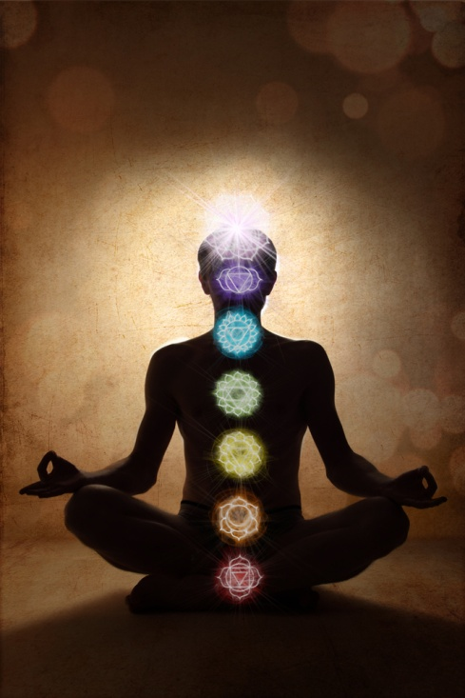
Mental disease or intuition.
Medical intuition.
The Chakras
The light Bodies.
Archetypes.
Architecture & structure of the universe.
The value of esoteric sciences such as; Numerology, Astrology, Geomancy etc.
Miracles Vs the process of healing.
Distance Healing, Face to Face Healing or Hands on Healing....what works where, when & for whom.
Quantum physics & Manifestation.
Practicing the Law of Attraction Effectively.
Dreams as tools to healing & evolution.
Nutrition & exercise to support Intuitives, magicians & healers.
The various types of Channelers (advantages & precautions).
Psychic Protection & Ethics for light workers.
Oracles & their value & uses; Tea leaves, Tarot, cloud readings, sand readings, Crystal Bowls etc
Crystals, Crystal grids & layouts, Crystal Feng- Shui.
Ghosts, space clearings, evil spirits etc
Psychic attack, Hexes, Curses, the Evil Eye.
Soul Family, Twin Souls, Soul Mates, Twin Flames
Chaos, Free will & choice Vs Destiny & Fate.
Energy cannot be crated nor destroyed ...the Philosophers stone.

Course will run 46 weeks year 1 & Year 2
Cost $80 for 3 hour class
Location, Epping / North Carlingford area.
(exact location TBA)

http://www.essential-energies.com.au/ ph;02 98685865
Nevine's mobile 0407660320

